Mrs. Battaglia’s Login Tips

Logging on using individual student information can be difficult for students. Kindergarten and first grade especially have a difficult time. I have created the following to help students practice the logon procedure at home. I know that this has many steps and in the beginning the younger students can be very frustrated. But, MANY students have already demonstrated their determination to succeed and have mastered this skill already.

I hope this guide helps you. I realize that on your home computer the screens may be different. If the can just practice typing the numbers and using the down arrow to come down to the second box, and using the shift key to type the capital P it would really help.

Students can use this table to practice. Have them type in their information and then just delete it and have them practice again.

Log on to Windows
USERNAME
PASSWORD

Log on to Windows
USERNAME
PASSWORD
(You will need to download this interactive form from the website so that your student can use it)

On the following page, I have created pictures of each step that the students must go through to log on with their individual district user ID and Password. This information will stay the same for your child as they progress through each grade level.
When the student sits down this is the first screen they see.

Students will press Ctrl + Alt + Delete to begin

(*Not all home computers are setup to do this)

I tell the students, “Make a V with the left hand, hold down these keys at the same time and don’t let them up – now push the delete key and let up all the keys.”  Hit the ENTER key | 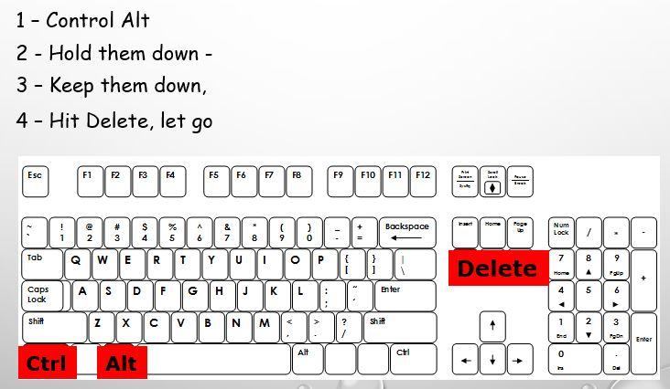

As the student types, have them place their finger on the paper under the number they are typing to help them keep their place on the ticket.  After typing in the user name numbers move the blinking line (cursor) to the second rectangle box by using the down arrow located by the number pad. | 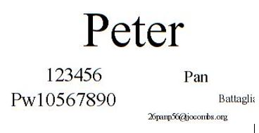

Remind the students at home they will see their numbers in the top and bottom rectangles, but at school they will only see black dots in the second rectangle. (On your home computer during practice they will see the Pw and numbers, it is at this time you can see where they are making mistakes and help them to correct them using the backspace key)  HIT ENTER KEY | 